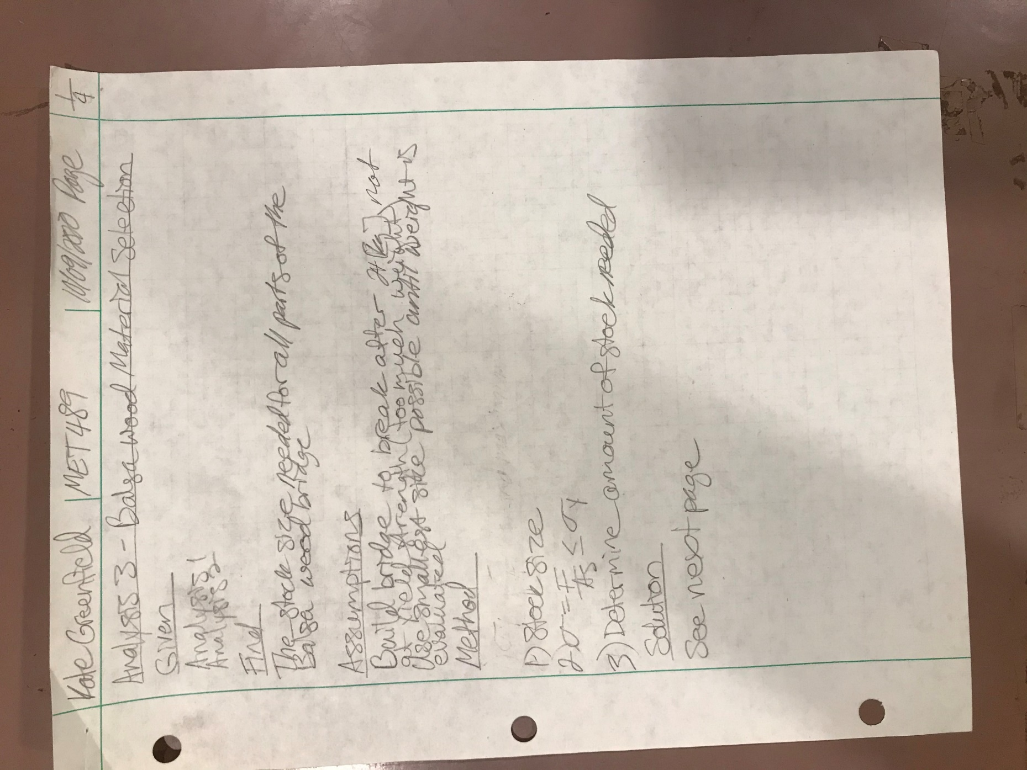
Figure 1. Page 1 of 4 of Balsa Wood Material Selection Analysis.
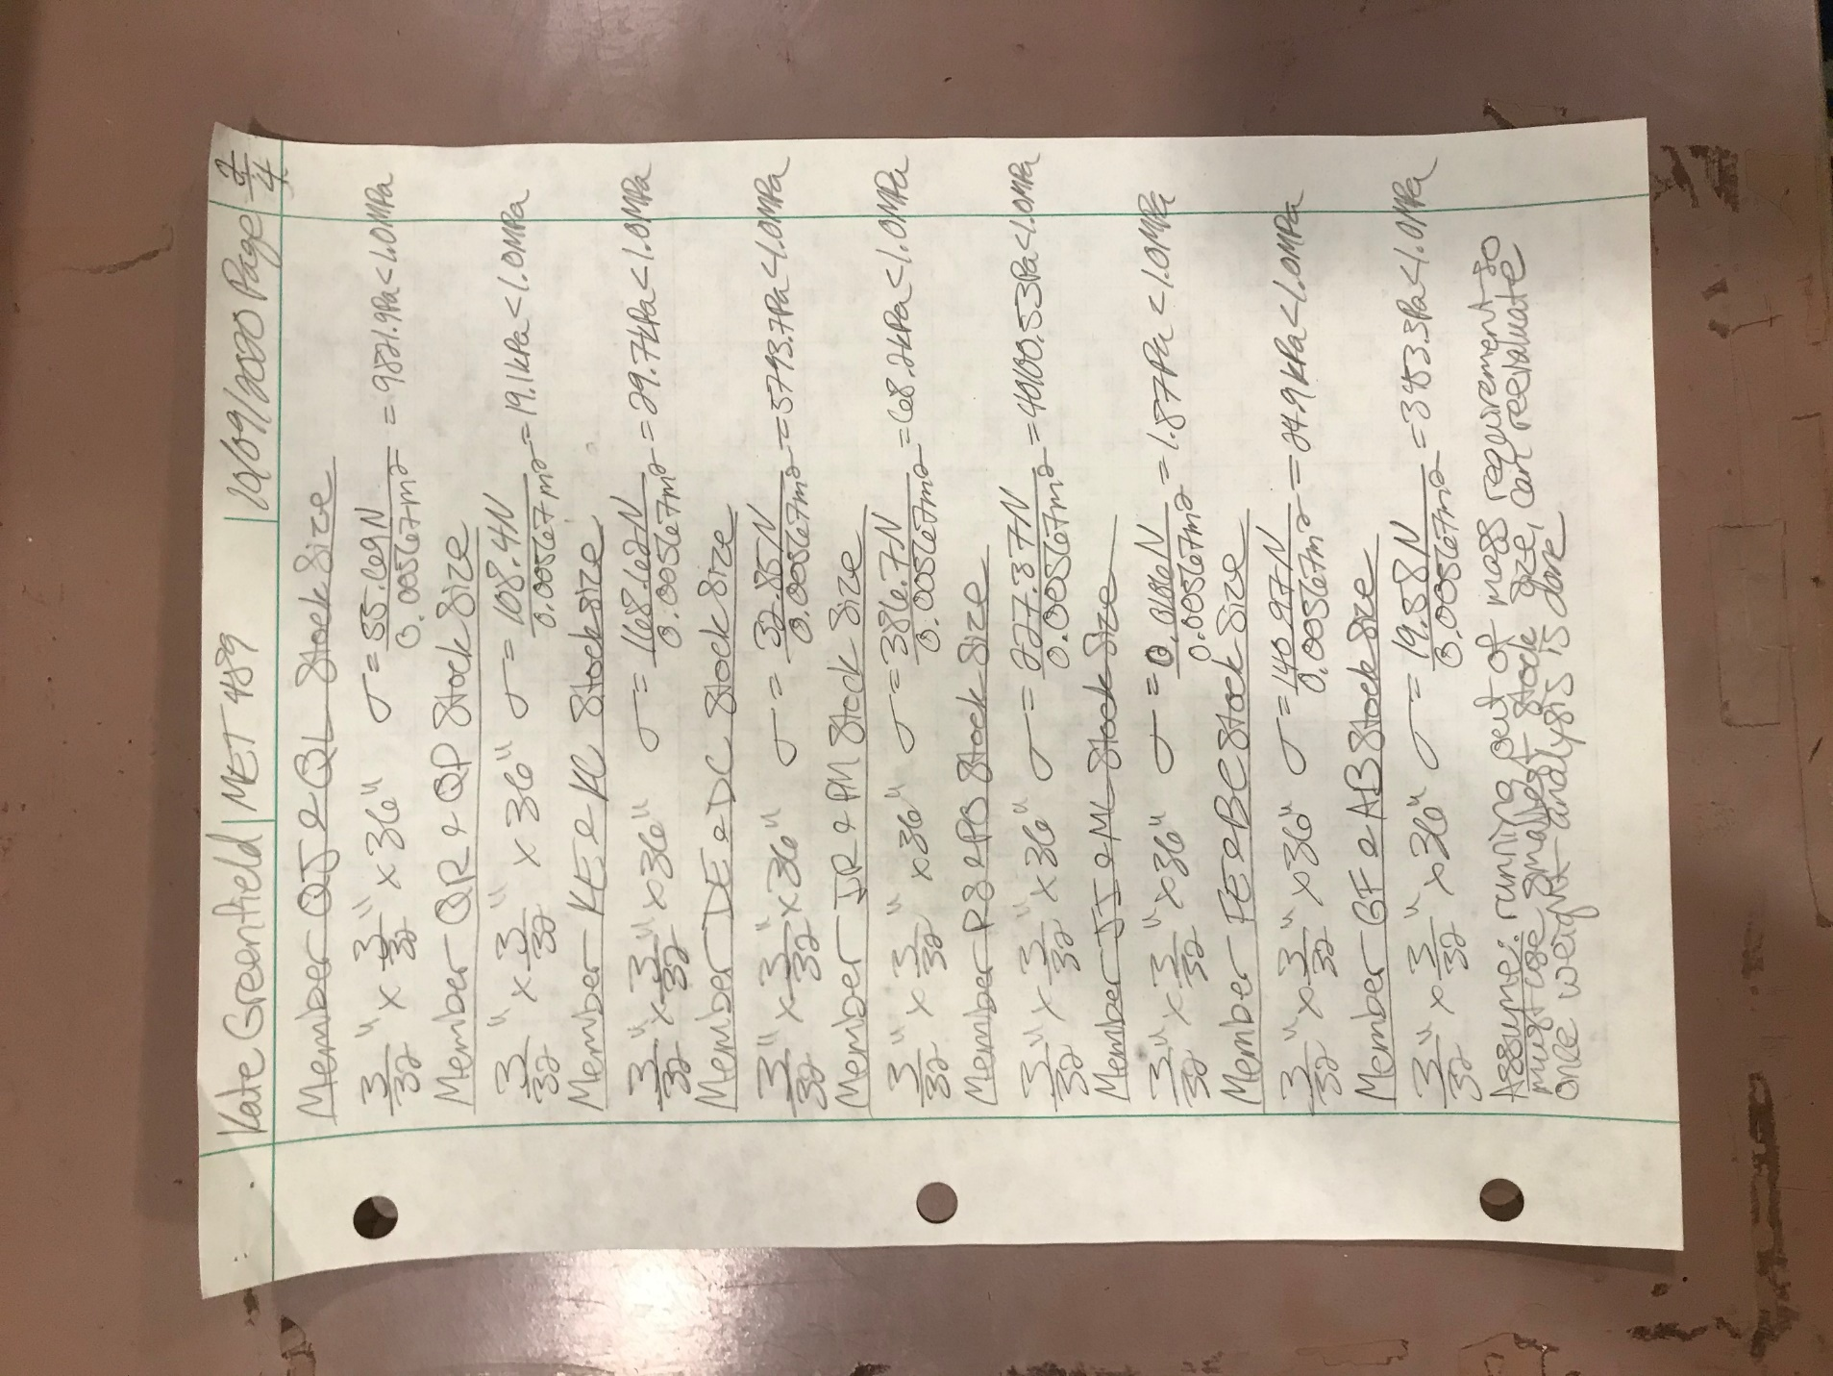
Figure 2. Page 2 of 4 of Balsa Wood Material Selection Analysis.
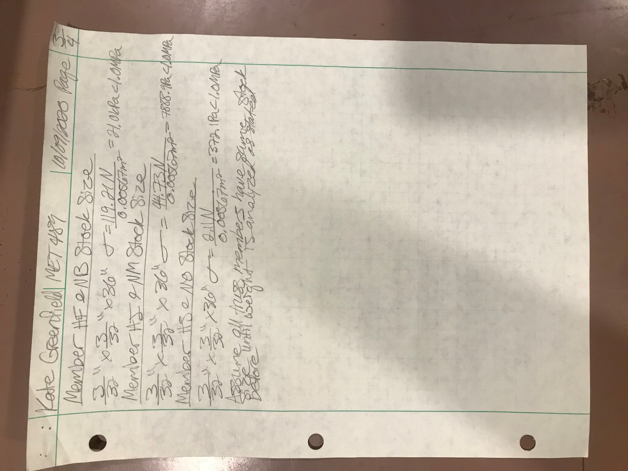
Figure 3. Page 3 of 4 of Balsa Wood Material Selection Analysis.
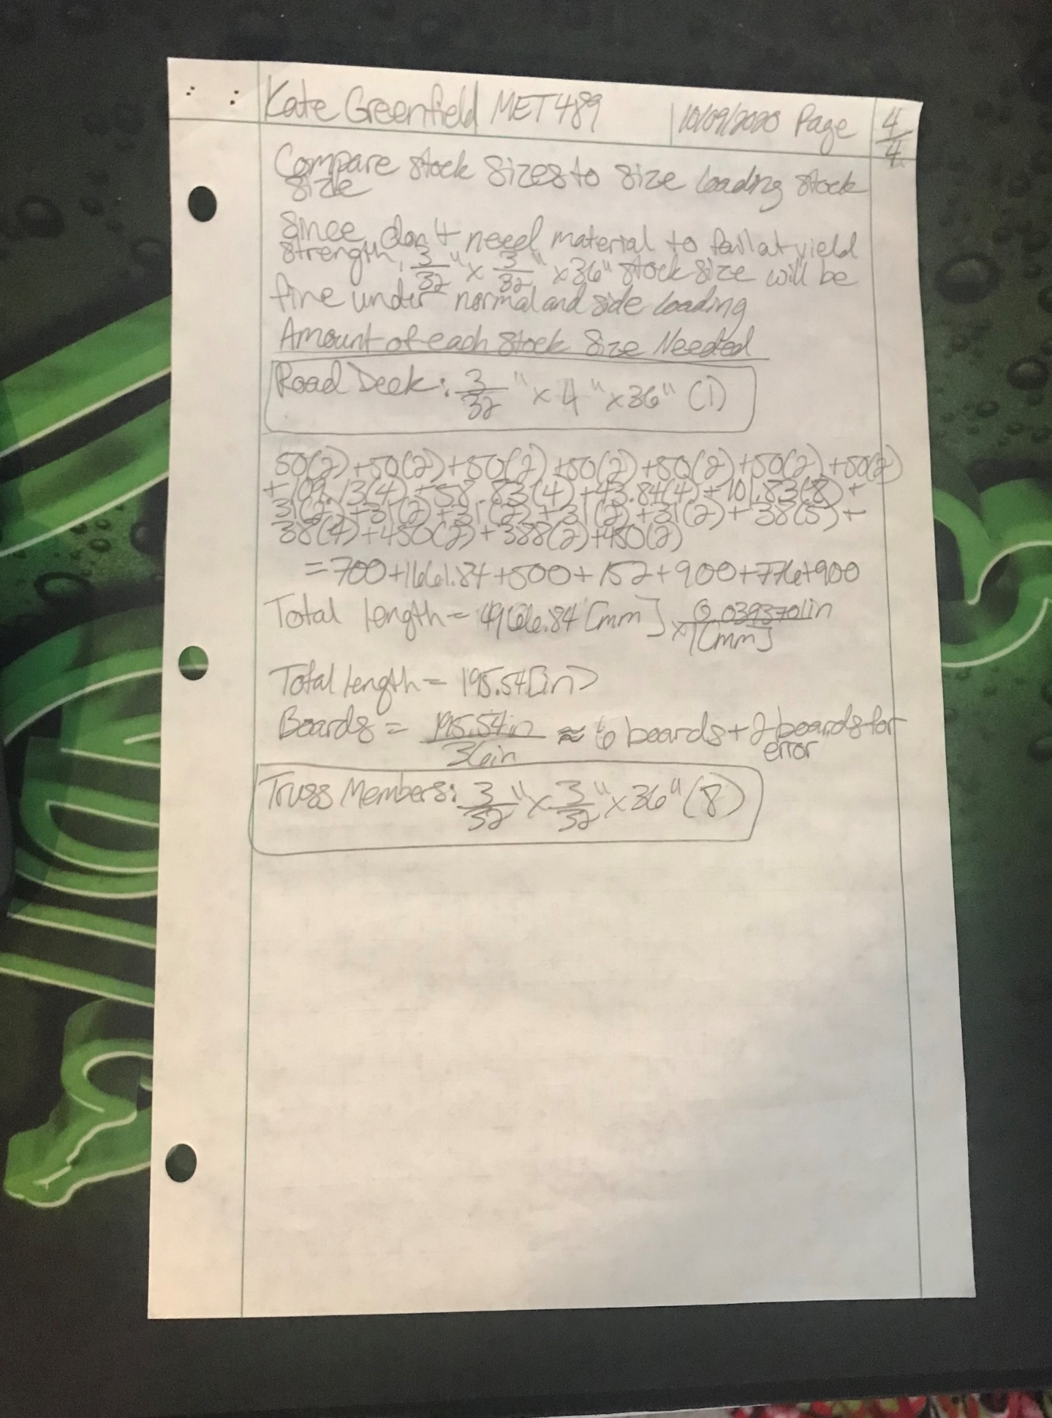
Figure 4. Page 4 of 4 of Balsa Wood Material Selection Analysis.

